**Face Recognition using Tensorflow**

**ABSTRACT**

Data science is "the idea of bringing together measurements, information examination, software engineering, and their connected techniques" to "comprehend and dissect genuine peculiarities" with information. It utilizes strategies and speculations drawn from many fields with regards to arithmetic, insights, software engineering, data science and area information. In any case, information science is unique in relation to software engineering and data science. Turing Grant champ Jim Dark imagined information science as the "fourth worldview" of science (observational, hypothetical, computational, and presently information driven) and contended that "all that about science is changing a direct result of the effect of data innovation" and the storm of information. .

The field of the Machine Learning can also be called as enabling or controlling the computers which makes their predictions successfully by using their past experiences, it has a successful development with the help of increase in the capacity of storage rapidly and processing of the computers power. The methods of Machine Learning had been employed widely in bioinformation also. There are difficulties and much cost in analysing biologically, and it has the development of Machine Learning sophisticatedly approaching for this area.

In this report we are going to know about the fundamental topics for Machine Learning , like Feature engineering, types of classification of Machine learning , applications related to the Machine learning, history related to Machine Learning, and we will learn about deep learning which is a subset of Machine learning, Tools of deep learning, what is perceptron, structure of neural network, Activation functions, Optimizers, CNN, RNN and finally we will know about Face recognition using TensorFlow.

Deep learning is a subset of AI that utilizes numerical capabilities to plan contribution to yield. These capabilities can separate non-repetitive data or examples from information, permitting them to lay out a connection among information and result. This is known as learning and the method involved with learning is called preparing.

**Introduction to Machine learning**

The Machine Learning term was created by a scientist ‘Arthur Samuel’ in the year of 1959. He is an American who works in the field of Computer gaming and AI. And he had stated that “AI gives the computers an ability for learning without programming explicitly”.

In the year of 1997, an scientist called ‘Tom Mitchell’ given a mathematical relational type definition that is “an computers program learns from the experience ‘E’ with something task called ‘T’ which is measured by ‘P’ and it again improves the experience ‘E’. “

ML can be called as the one of the best interesting subfields in Artificial intelligence and Computer science also.

If we take an example called throwing a ball for understanding about ML briefly, for example in first attempt we will come to known that we must apply an much force on it, after completion of second attempt we will come to know that we have change some throw angle in it to reach the target. Here what is happening is after completion of every attempt we are learning something, and we are trying to improve our self. That means we are programmed to learn from our experience for better result.

This example follows the proposal of Alan Turing that “Computing Machines and their Intelligence” in which a question that “can machines think “can be replaced with the question “can Machines do what we can do”

When we consider the field of Data analytics, ML is used to solve the tuff or complex problems and Algorithms that are lead to Predictions by themselves. This is known as predictive analytics. These analytic models can be useful for researchers to produce ‘reliable, repeatable decisions, and results.

For example, you are decided to go for a vacation, we will go through any travel agencies websites, and we will search an hotel for vacation, when you check for hotels at down you will see a specified title that, “you may also like these hotels!”. This is an example of Machine Learning.

Suppose if you want to create a program of predicting the traffic signals patterns, in the case of busy Intersection called task’s’ the Machine Learning data with algorithm learns from the past traffic patterns called experience ’E’. If the program learned perfectly from past, it will perform perfectly in future predictions also called performances’’.

There are so many highly complex real world problems in the world, by inventing specialized algorithms, they will solve them perfectly every time. The example complex problems which can be included in Machine Learning are “is this cancer?”, “will that person likes sports?”. The problems like these models are excellent targets for ML.

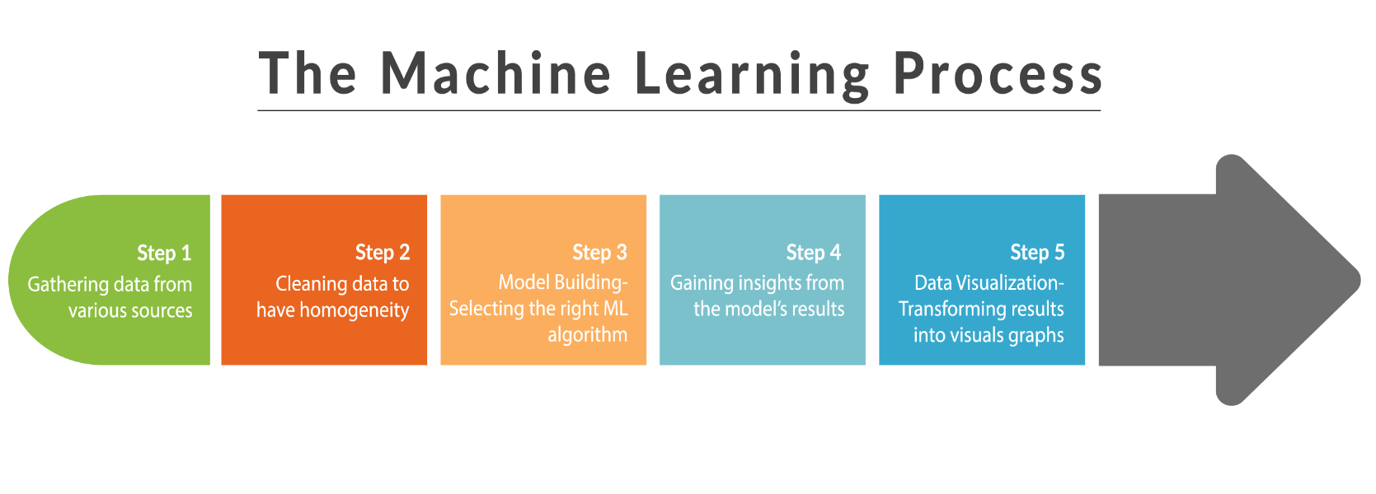

**Fig1.** Steps in Machine Learning

**Classification Of Machine Learning.**

There are three main types of classifications in MACHINE LEARNING. These classifications are classified based on the nature of the learning, which are as following:

**Fig2.** Classification of Machine learning

**1)SUPERVISED Learning:**

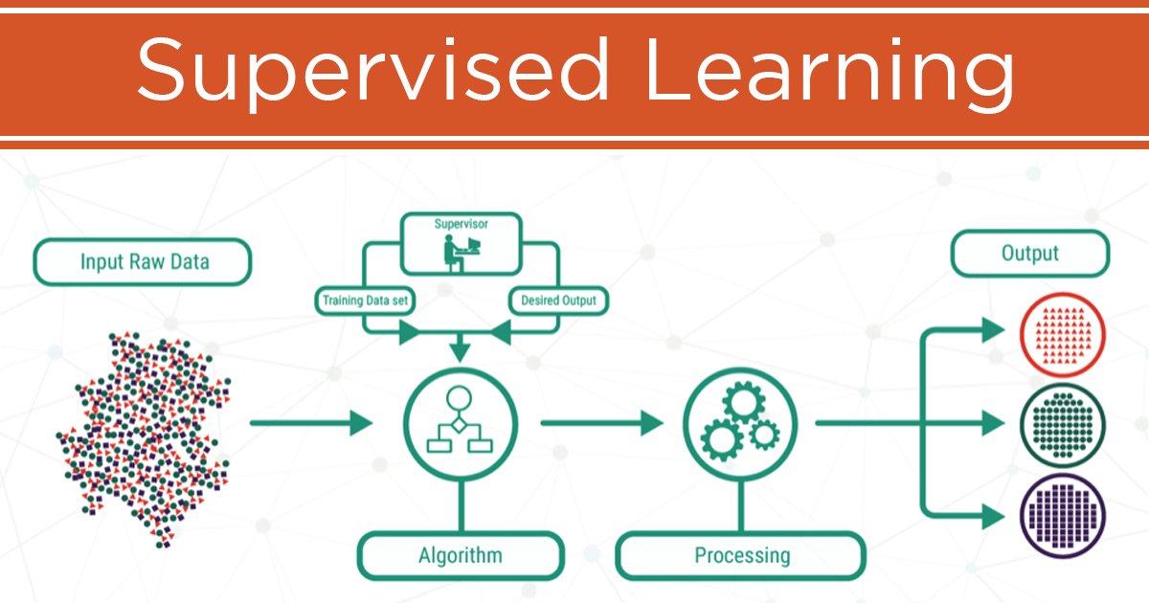

**Fig3.** Supervised learning process

Supervised Learning is also known as for example take a function called Y=f(X), where x is called input variables and y is called an output variable. The above function is an algorithm. It learns to map the function from input to the output.

The goal of this algorithm is to a map so that the above fnction so if that we give an new input data (x) we can get the variables of the output (y) for that given data.

This type of process is known as Supervised Learning because the algorithms process learns from the data can called as teacher, the algorithms automatically make predictions on the training data, and it will be corrected by teacher. This Learning will stop when it reaches the perfect level of performance.

It is also known as labelled data learning. If we give the input to the computer as the weight of one-rupee Indian currency is 3 grams, French currency is 7grams and in German currency is 5 grams. Now if we give an empty coin of 3 grams it identifies as one-rupee Indian currency.

**2)UNSUPERVISED Learning:**

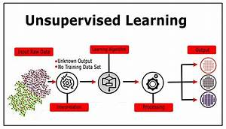

**Fig4.** Unsupervised machine learning process

Unsupervised learning also known as when we consider a algorithm, if it trying to learn plain examples without any type of response, and again leaving to the algorithm to find out or to determine the Data patterns on its own. These types of algorithms can be tends to redesign or restructure the data into something else like it may represent the new series of Un correlated value.

It is also known as unlabeled data learning because it clusters the given input data. It will give an unknown output and it don’t contain training data set. It will resemble with the methods of human beings to figure out certain objects, for example observation of degree of similarity between the two objects. Marketing automation which is an example of Recommendation system is based on the Unsupervised Learning.

**3)REINFORCEMENT Learning:**

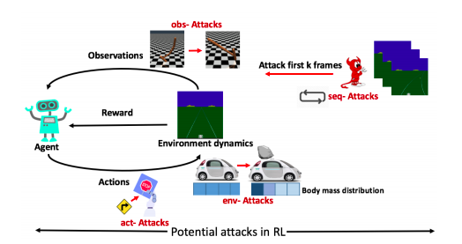

**Fig5.** Steps in Reinforcement learning

In this type of Learning it learns from the errors. Because it is added with an penalty. So we can say that errors help you to learn. These penalties can add Cost, Loss of Time,Pain e.t.c., this Learning works on the princple of feedback, a best example for Reinforcement Learning is computer playing the video games by itself.

Simply reinforcement learning is a reward base learning or it works on the principle of feedback. For example if we give dog image to the computer if it gives the output as it is cat then we have give feedback that no it is a dog, after that give another type dog image. It learns and give that it is a dog. This is called reinforcement learning.

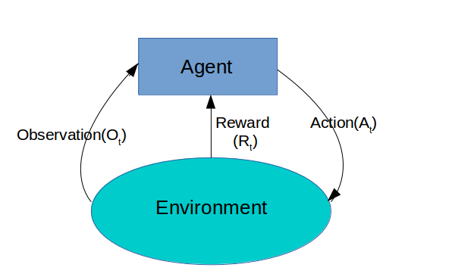

**Fig6.** Working of a agent in reinforcement learning

**Introduction to Deep Learning**

Deep learning is a part of AI that is totally founded on fake brain organizations, on the grounds that the brain organization will in the copy of an humanic cerebellum, so profound is the learning of the an sort of impersonation of the humanic mind. In dl, do not have to program the everything expressly done. As processing power increments dramatically throughout the course of recent years, profound learning and AI have entered the scene.

Deep learning is an exceptional sort of AI that accomplishes of the extraordinary an power and to the perfect adaptability on doing by figuring the out of how address to the world in the scenario as a settled of us can order of different ideas, with damn every perfect idea is incorrect to characterized the on doing comparable to came as less complex ideas and more dynamic portrayals registered with concerning respect to less the unique any another ones.

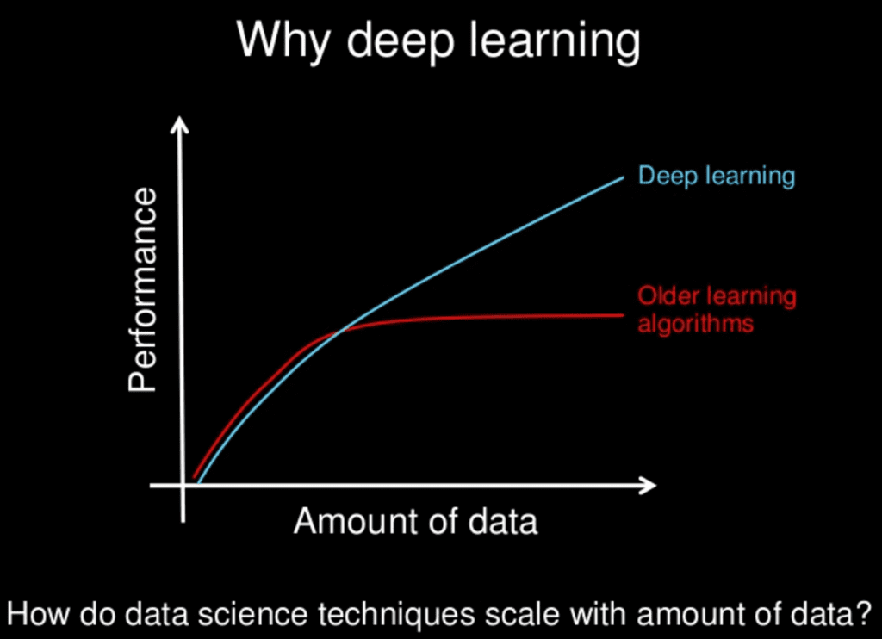

**Fig7.** Comparison of deep learning and other algorithms

**Perceptron**

The Perceptron was introduced by Direct Rosenblatt in 1957. He proposed a Perceptron learning rule considering the principal MCP neuron. Perceptron is an estimation for coordinated learning of matched classifiers. This estimation grants neurons to learn and manage the parts in the arrangement set one by one.

Perceptron is ordered into two kinds; those are Single layer perceptron and Multi-facet perceptron

Single layer - Single layer perceptron's can learn just straightly detachable examples

Multi-facet - Multi-facet perceptron's or feedforward brain networks with at least two layers have the more prominent handling power which is otherwise called a total brain organization.

Perceptron Learning Decide states that the calculation would naturally become familiar with the ideal weight coefficients. The information highlights are then increased with these loads to decide whether a neuron fires or not.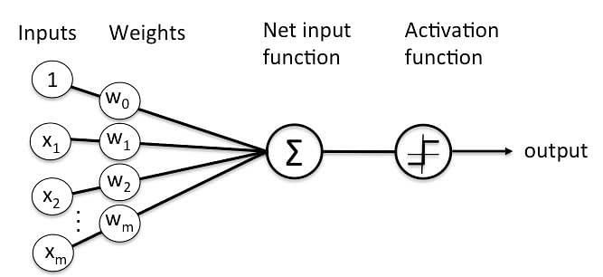

**Fig8.** Working of a perceptron

**Layers in Neural Network**

A brain network is worked by layers which will be attached like at stack. In the underneath given picture the in an upward direction spotted lines address the layers. There are complete three sorts of layers in a brain organization.

Input Layer-First is the info layer. This layer will acknowledge the information and pass it to the remainder of the organization.

Hidden Layer - The second kind of layer is known as the secret layer. A brain network has it is possible that at least one secret layers. In the above case, the number is 1. The secret layers are liable for the predominant presentation and intricacy of brain organizations. They carry out various roles simultaneously, like information change, programmed component creation, and so on.

Output Layer - The last kind of layer is the result layer. The result layer contains the outcome or result of the issue. The crude pictures are passed to the info layer and we get the result in the result layer.

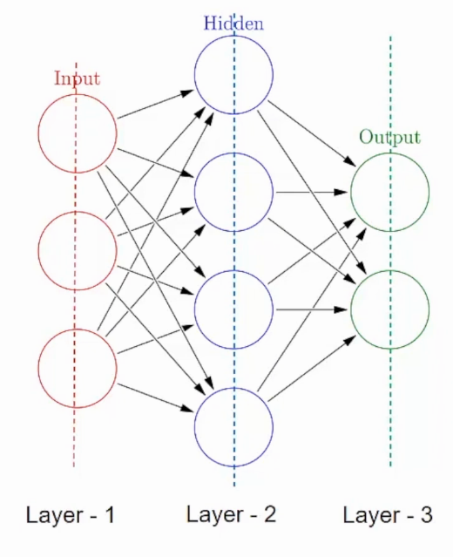

**Fig9.** Layers in a neural network

**Activation Functions in Neural networks**

Since it has become so obvious how a brain network consolidates various sources of info utilizing loads, we should continue on toward the last part of a neuron called the enactment capability. Up until this point we've basically added a few weighted inputs and determined some result, and that result can peruse from short endlessness to limitlessness.

Be that as it may, this can be tested much of the time. Assume we first need to gauge an individual's age from their level, weight, and cholesterol level, and afterward group the individual as old or not in view of whether they are more seasoned than 60 years.

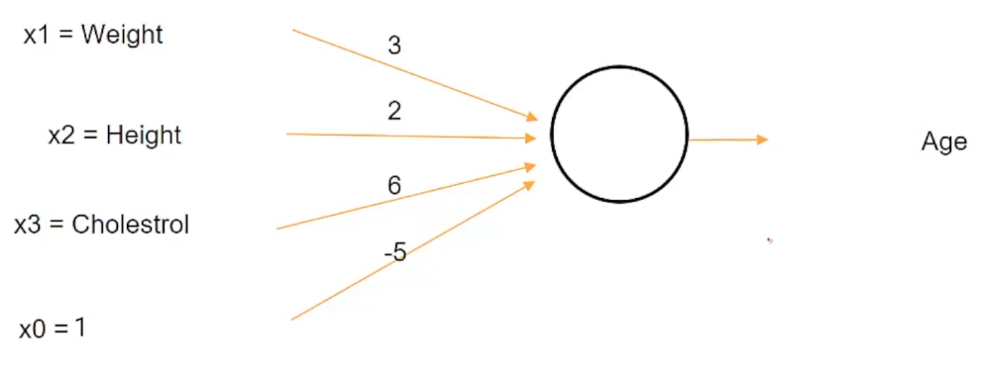

**Fig10.** Working of a node in neural network

Presently, assuming that we utilize this given neuron, a time of - 20 is even conceivable. You realize that the age range as indicated by the ongoing construction of this neuron will be from - ∞ to ∞. So even somebody's time of - 20 is conceivable, considering this ludicrous reach for age we can in any case utilize our status to choose if an individual is old or not. For instance, on the off chance that we said a specific measure like an individual is old, provided that the age is over 60 years. So regardless of whether the age emerges to - 20, we can utilize this measure to arrange the individual as imperishable.

Contingent upon the sort of change required, there can be various types of initiation capabilities. We should investigate some famous initiation highlights -

**1.Sigmoid Activation Function**

This capability changes the scope of consolidated contributions to a reach somewhere in the range of 0 and 1. For instance, assuming the result is from short endlessness to vastness, which is addressed by the x-hub, the sigmoid capability will restrict that limitlessness. reach to a worth somewhere in the range of 0 and 1.

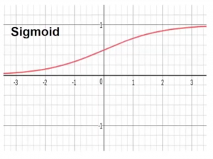

**Fig11.** Sigmoid activation function

**2. Tanh Activation Function**- This capability changes the scope of consolidated contributions to a reach between - 1 and 1. Tanh looks basically the same as a sigmoid shape, however restricts the reach to between - 1 and 1.

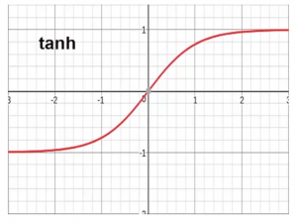

**Fig12.** Tanh activation function graph

**3. Activation function ReLU (Rectified Linear Unit).**

ReLU is the only currently on the most of the used activation function as we know in the world. After that it has the popular in every convolutional neural networks.

**Fig13.** Comparison of sigmoid and relu graphs

**4. Leaky ReLU**

It is an endeavor to take care of the perishing ReLU issue. In Relu on account of negative worth it will simply give the result as nothing, so there will be no updation in the loads. So Due to Relu actuation capability there is no utilization of Back spread. To settle this Flawed Relu is created in which this capability will acknowledge a less scope of negative worth.

**Fig14.** Leaky relu activation function

**5. Threshold Activation Function**

This activation function will works as if x >0 it will produce 1 as output otherwise it will produce 0 as output.

**6. Softmax Activation Function**

Softmax is an actuation capability that converts logits to the probabilities. The result of a Softmax will be a vector with every conceivable result of probabilities. The probabilities in vector v aggregates to one for every single imaginable result or classes. Numerically, Softmax is characterized as,

**Fig15.** Formula of softmax function

**Optimizers for Neural Network**

Analyzers are characterized as they are the methodology utilized during the time spent Backpropagation and the Backpropagation implies refreshing the loads and predisposition upsides of the brain networks in preparing process as for loss of brain organization.

How you ought to change your loads or the learning pace of your brain organization to diminish misfortunes is characterized by the analyzers you use. Enhancement calculations or methodologies are answerable for diminishing misfortunes and giving the absolute most precise outcomes.

Types of optimizers

1) Gradient descent

Angle Drop is essential yet super applicable function in the dl. It is casually utilized in direct relapse so that in calculations. Backpropagation uses the slope of an plunge calculation in neural networks.

Inclination plunge is a the first-request of streamlining an calculation can that relies nested upon to the subordinate can of the first-request by the misfortune in the capability. It works out how the loads bought for to be the changed can be with of to the goal in to that the capability per annum can for to arrive at any time rate. Through the arrival of the per epoch backpropagation, the misfortune is moved starting with the one and only one layer with then onto welcome to the next and the bye to the model carb verb boundaries, otherwise things will be called to hell of loads with virtusa, are changed for the reason on relying upon the misfortunes so the misfortune can the be not limited.

calculation: θ=θ−α⋅∇J(θ)

2) Stochastic gradient descent

It is a variation of Inclination Plummet. It attempts to refresh the model boundaries on a more regular basis. In this, the model boundaries are changed in the wake of computing the misfortune on each preparing model. So if the dataset contains 1000 lines, SGD refreshes the model boundaries multiple times in one dataset cycle rather than once as in Slope Plummet.

3) Mini batch gradient descent

It is awesome of all variations of inclination drop calculations. It is an enhancement for both SGD and standard plunge. Refreshes model boundaries after each bunch. In this way, the dataset is separated into various bunches and after each clump the boundaries are refreshed.

4) Momentum

Energy was designed to decrease high change in SGD and mellow combination. It speeds up the union to the significant course and lessens the variance to the immaterial heading. In this strategy, one more hyperparameter known as energy represented by "γ" is utilized.

V(t)=γV(t−1)+α.∇J(θ)

5) Adagrad

One of the impediments of all made sense of enhancers is that the learning rate is steady for all boundaries and for each cycle. This analyzer changes the learning speed. It changes the learning rate 'η' for every boundary and at each time step 't'. It is a sort of second-request improvement calculation. It chips away at the subordinate of the blunder capability.

The subordinate of the misfortune capability for the given boundaries at the given time t

6) AdaDelta

An AdaGrad augmentation will in general dispense with the learning rot issue. Rather than collecting all recently scaled changes, Adadelta limits the window of amassed past advances to some proper size w. In this, an outstanding moving normal is utilized as opposed to the amount, everything being equal.

E[g²](t)=γ.E[g²](t−1)+(1−γ).g²(t)

7) Adam

Adam (Versatile Second Assessment) works with first-and second-request momenta. The instinct behind Adam is that we would rather not look over that quick to make sure we can skirt the base, yet we need to dial back a piece for cautious looking. As well as putting away the dramatically diminishing mean of past quadratic angles like AdaDelta, Adam additionally stores the dramatically diminishing mean of past slopes M(t).

M(t) and V(t) are the upsides of the primary second, which is the mean worth, and the subsequent second, which is the uncentered change of the angles

**Tools Used for Implementing Neural Networks**

**1. TensorFlow**

TensorFlow is a profound learning device that was written in exceptionally improved C++ and CUDA (Nvidia's GPU programming language) and gives connection points to dialects like Python, Java, Go. It is an open source library created by the tech monster Google to run profound learning applications easily.

TensorFlow makes it simple for amateurs and even specialists to fabricate AI models for portable, web, work area and cloud.

Making huge scope brain networks with numerous layers is additionally utilized. To address profound learning or AI issues like characterization, insight, figuring out, disclosure, expectation, and creation, TensorFlow is the right profound learning apparatus for you.

**2. Keras**

Keras is an undeniable level brain network Programming interface that is equipped for running on top of TensorFlow or Theano. It is written in Python and was grown fundamentally to empower quicker trial and error. The Keras profound learning library makes prototyping simpler and quicker for the client utilizing particularity, moderation and simple extensibility.

Keras is a profound learning device that upholds repetitive organizations and convolutional networks separately and in blend of both. It likewise upholds preparing with various sources of info and results. It follows best practices to decrease mental burden by offering criticism when any blunder is recognized.

**3. Torch**

Torch is a strong open source program that utilizes the LuaJIT prearranging language and C/CUDA execution. In the event that you utilize this profound learning apparatus, you will actually want to exploit its strong elements, for example, different schedules for ordering, rendering, cutting, astounding point of interaction to C by means of LuaJIT, brain organization. It offers quick and proficient GPU support and is not difficult to implant, making it simple to work with iOS, Android, FPGA.

**4. H2O.ai**

H2O is a profound gaining device that was worked starting from the earliest stage in Java and expands on consistent joining with other open source items like Apache Hadoop and Flash. It has a simple to-utilize online UI and is greatly versatile in enormous information examination.

H2O, an open source profound learning instrument, upholds the most generally utilized AI calculations. It is a quick, versatile AI application interface utilized for profound learning, flexible organization, strategic relapse, slope supporting; to give some examples. H20 makes it more straightforward for anybody to utilize AI calculations and prescient examination to take care of any business issue.

**5. DeepLearningKit**

DeepLearningKit is an open source profound learning device for Apple iOS, operating system X, tvOS, and so on. The principal thought behind its creation was to help pre-prepared models on all Apple gadgets that have a GPU. This profound learning apparatus is created in Quick and can be utilized on GPU gadgets to perform profound learning estimations with low idleness. DeepLearningKit additionally upholds convolutional brain organizations. His vision is to help other profound learning devices like Light and TensorFlow.

**Face recognition using Tensorflow**

Facial acknowledgment is a strategy for distinguishing or affirming an individual's character in light of their face. Facial acknowledgment frameworks can be utilized to recognize individuals in photographs, recordings, or progressively.

Facial acknowledgment is a class of biometric security. Different types of biometric programming incorporate voice acknowledgment, unique finger impression acknowledgment, and retinal or iris acknowledgment. The innovation is basically utilized for security and policing, however there is developing interest in other application regions.

Many individuals are know about the FaceID facial acknowledgment innovation used to open iPhones (albeit this is only a facial acknowledgment application). As opposed to depending on a colossal information base of photographs to decide a singular's character, facial acknowledgment regularly basically distinguishes and perceives the person as the sole proprietor of the gadget, restricting admittance to different clients.

As well as opening telephones, facial acknowledgment works by matching the essences of individuals who pass before an exceptional camera to pictures of individuals on your watchlist. Watchlists can incorporate pictures of anybody, even the people who are not associated with cheating, and the pictures can emerge out of anyplace, even from their virtual entertainment accounts. Facial innovation frameworks might shift, however by and large work as follows:

Stage 1: Face Recognition

The camera perceives and finds pictures of countenances, either alone or in a group. The picture can show an individual confronting front or profile.

Stage 2: Face Investigation

Then, facial pictures are caught and examined. Most facial acknowledgment advances depend on 2D pictures instead of 3D pictures. This is on the grounds that 2D pictures can measure up more helpfully with public photographs or photographs in a data set. The product peruses the state of your face. Significant variables incorporate the distance between the eyes, the profundity of the eye attachments, the separation from the temple to the jawline, the state of the cheekbones, the forms of the lips, ears and jaw.

The objective is to distinguish key facial elements to recognize faces.

Stage 3: Convert Picture to mathematical Information

face catch process changes over simple data (the face) into a progression of computerized data (information) in view of the individual's facial elements. Facial examination basically transforms into a numerical recipe. Numeric codes are called faceprints. Every individual has an exceptional facial print, very much like their thumbprint is remarkable.

Stage 4: Find Matches

Then, at that point, balance the headshot with a data base of other known faces. For example, the FBI approaches up to 650 million photos from various government informational collections. On Facebook, any photo marked with a singular's name ends up being significant for Facebook's informational collection and can similarly be used for facial affirmation. In case the face print matches the image in the facial affirmation informational collection, a decision is made of all biometric assessments, facial affirmation is considered the most typical. Normally, this gives off an impression of being genuine, since we for the most part see ourselves as well as others by our faces instead of our thumbprints or irises. It is evaluated that most of the complete people are introduced to facial affirmation advancement reliably.

In this project we are using a architecture called Siamese network, this network will take two images for training process with labels 0 or 1. We will make three datasets one will contain our image with different angles, second one will contain our images only same as first one, third one contain the images of other people. All these datasets have 500 images each. Now randomly we will take the image from first dataset and combine with second and third datasets, if the first image and second image are belonging to same person then we will give the label as 1 otherwise we will give the label as 0. Like this we will make a dataset and we use keras sub modelling and custom training loop topics to create our model which works same as the Siamese model and we will start the training process. After training completes, we can use the same model for face recognition, first we have to collect the images of the authorized user and we will store it in a folder, after that we will take a image input and send it with every image the authorized person has saved and if it is having atleast 80% threshold then it will print as person is authorized otherwise it will print it as not authorized.

**Results**

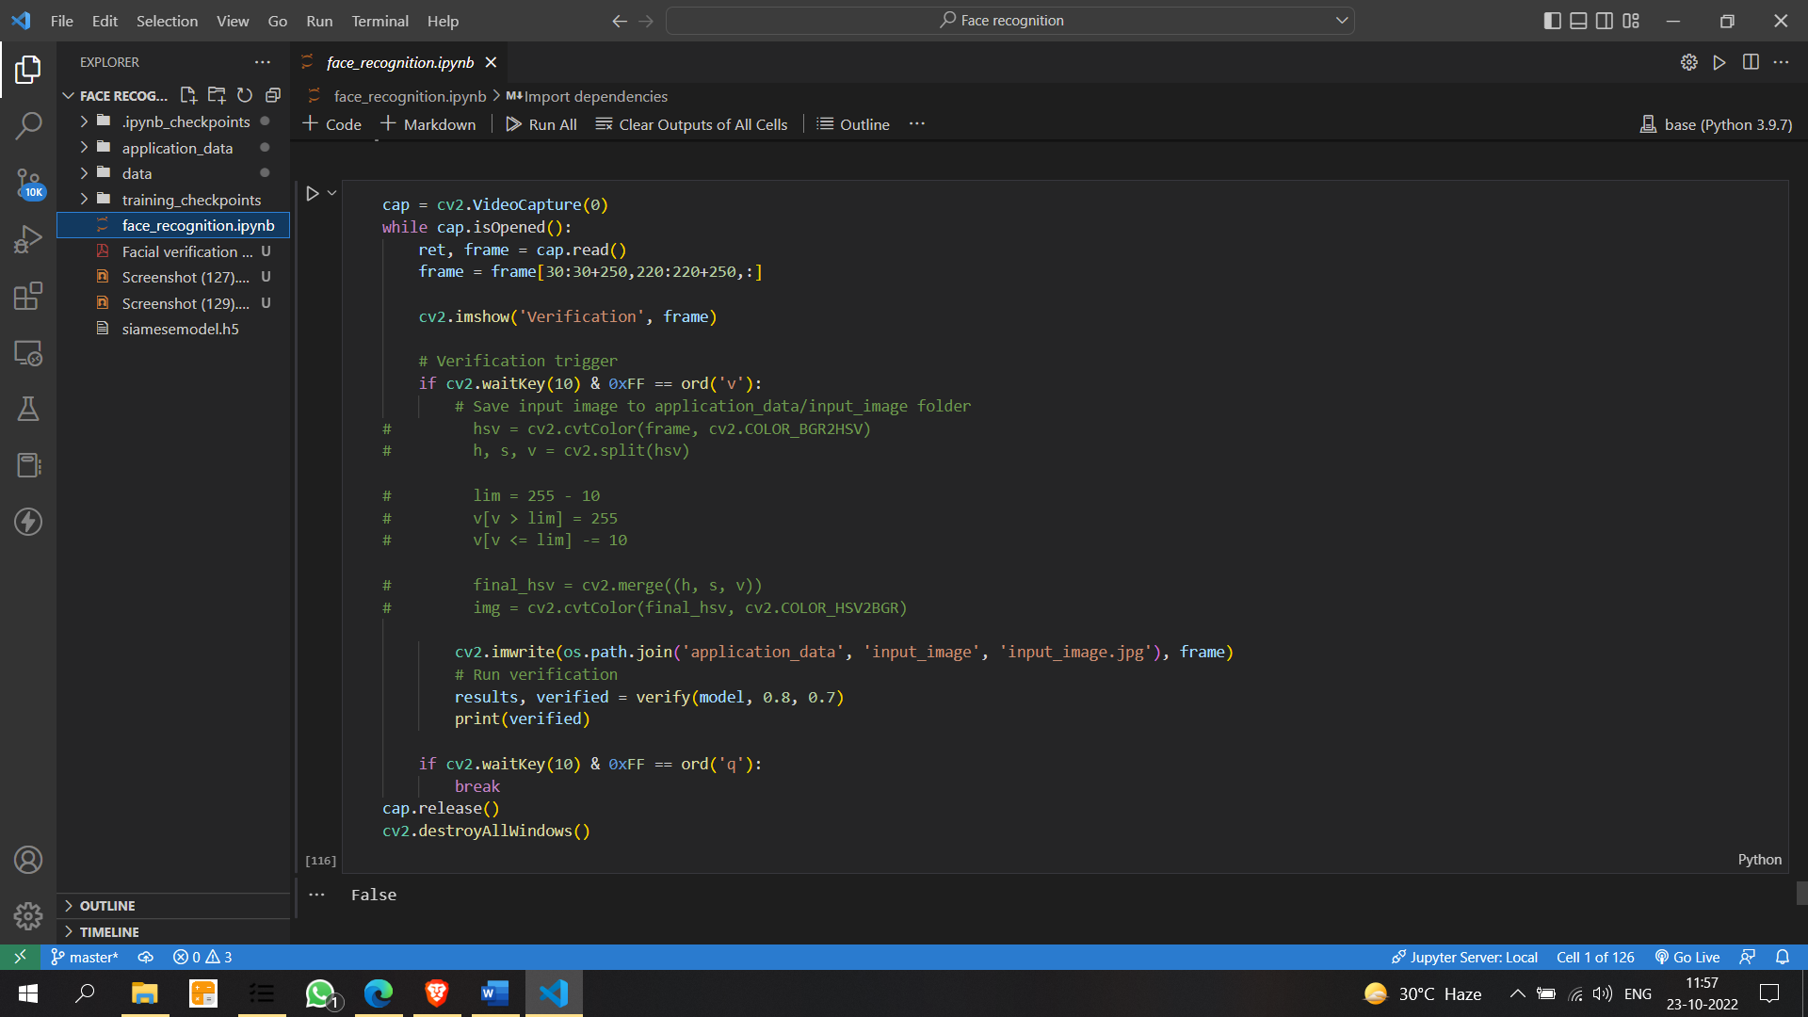

**Fig16**. Output of the face recognition model

**Conclusion:**

Facial recognition is a method of identifying or confirming a person's identity based on their face. Facial recognition systems can be used to identify people in photos, videos, or in real time.

Facial acknowledgment is a classification of biometric security. Different types of biometric programming incorporate voice acknowledgment, unique finger impression acknowledgment, and retinal or iris acknowledgment. The innovation is principally utilized for security and policing, yet there is developing interest in other application regions.